**Question 19:** **( 18 marks )**

**The Mass of an Electron**

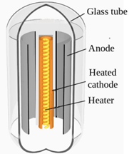A tuning eye tube, also known as a magic eye tube, is a vacuum tube where electrons are released from a hot cathode at the centre. The electrons are then accelerated towards two anodes. The anodes form a semi-circular funnel shape around the cathode. These electrons are accelerated towards the anode by an accelerating voltage (Va). Refer to Figure 1 for more details on the structure of this tube.

**Figure 1:** Tuning eye tube

When the accelerated electrons hit the anode fluorescence occurs, releasing a pale green light. The pattern that the fluorescent light forms is that of two fan-shaped beams of light with straight edges, as shown in Figure 2a and 2b below.

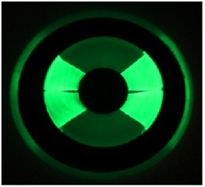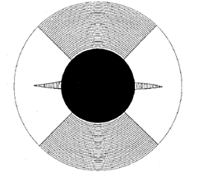

**Figure 2a**: Top view of the fluorescent **Figure 2b:** Actual image of the

pattern when the tuning eye tube is not fluorescent pattern without

exposed to a magnetic field. exposure to a magnetic field.

The tuning eye tube is then placed inside a solenoid as shown in Figure 3 below.

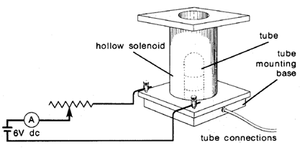

**Figure 3:** Tuning eye tube placed inside a solenoid that is connected to a variable resistor which allows current to the solenoid to be adjusted.

When a particular current is passed through the wire coils of a solenoid, a uniform magnetic field is generated inside the solenoid. Thus the electrons in the tube experience a uniform magnetic field, shown in Figure 4.

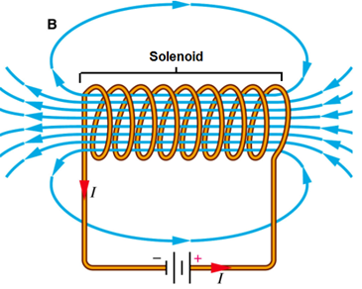

**Figure 4:** Uniform magnetic field inside a current conducting solenoid

The magnetic force is supplying all the centripetal force, since the tuning eye tube is a vacuum tube. When the tube is exposed to a uniform magnetic field the electrons are deflected by this magnetic force into a circular arch that has a measurable radius of curvature, R as shown in Figure 5a and 5b. The radius of curvature, the strength of the magnetic field inside the solenoid, and accelerating voltage are all used to determine the mass of the electron.

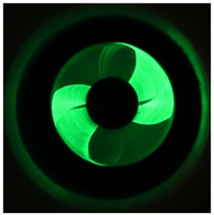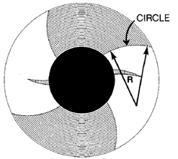

**Figure 5a:** The electrons are deflected by the **Figure 5b:** Actual image of tube

magnetic field to create an arch that has a exposed to a magnetic field.

measurable radius of curvature, R.

(a) The equation for the mass of an electron is:

m = R2qB2 2Va

1. Starting with the equation for the work done on the electron then using force equations derive the above equation for the mass of an electron. ( 3 marks )
2. If the edge of the fanned out beam is arched to have a radius of curvature of 1.16 cm in a magnetic field of 4.5 mT and the tube has a voltage of 240 V then what is the mass of an electron according to this study? ( 2 marks )

(b) i. Using 9.11 x 10-31 kg as the mass of an electron and given that the voltage difference across the anode and cathode is 240V and assuming the electrons released from the cathode have no initial velocity, determine the acceleration of the electrons towards the anode. ( 2 marks )

ii. If protons were used instead of electrons state by how many times the voltage would need to increase to get the protons to achieve the same acceleration as the electrons. Show your calculations. ( 2 marks )

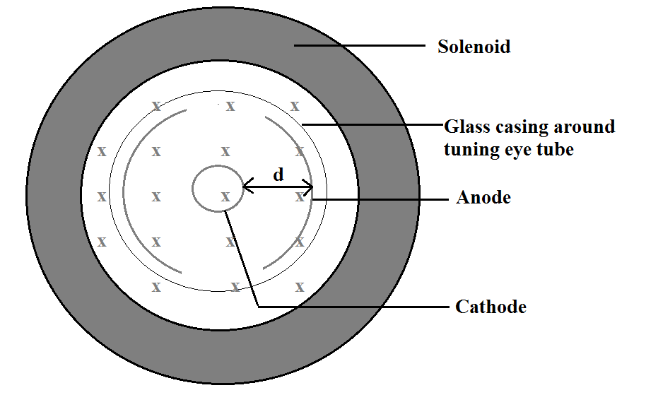(c) Given that the mass of an electron is 9.11 x 10-31 kg and that the initial velocity of the electron leaving the cathode is zero. Use the average velocity of the electron as it travels towards the anode, perpendicular to the magnetic field, to estimate the magnitude of the deflection due to a magnetic field strength of 250 µT. The distance between the anode and cathode is 1.00 cm. Note: The accelerating voltage supplied to the tube is still 240V. If you were unable to solve for the acceleration in part (b) i. then use a value of 4.40 x 1013 ms-2. ( 8 marks )

**Figure 6:** Tuning eye tube inside a solenoid that is producing a magnetic field

d) Using the information show in figure 6 in part (c) determine if the electrons are deflected in a clockwise or anticlockwise direction. ( 1 mark )

___________________________________________________________

**Question 20:** **( 18 marks )**

**Coulomb’s Law**

The electrical force that electrically charged particles can exert on each other is much stronger than the gravitational force. The strength of the electrical force can be expected to depend on the magnitude of the charges and on the distance between them. The formula governing the exact nature of the relationship or very small charged particles has become known as Coulomb’s Law (after Charles-Augustin Coulomb, 1736-1806).

The methods used to study Coulomb’s Law all involve balancing the electrical force with other forces that are easier to measure.

In the PSSC-type Coulomb’s Law Apparatus shown in Figure 7 a pith ball (a Styrofoam low mass ball) is suspended on a light weight string in such a way that its movement is confined to one plane. A grid is placed under the pith balls, with a ruler placed behind the grid allowing easy measurement of distances.

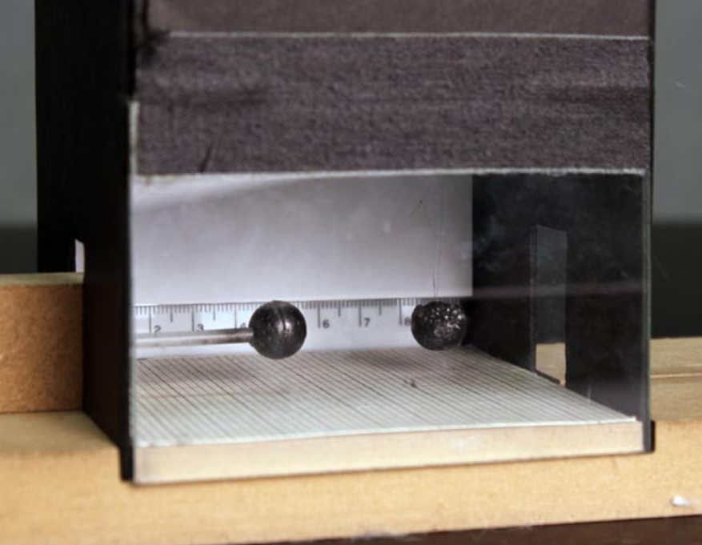

**Figure 7**: PSSC-type Coulomb’s Law Apparatus

The pith ball is then electrically charged by transferring electrons onto it using a charged acetate strip. An identical pith ball is given an exactly equal charge using the same acetate strip. This second pith ball is then placed a distance, R from the first pith ball. This causes the suspended pith ball to deflect a linear distance, d, as shown in Figure 8 on the next page.

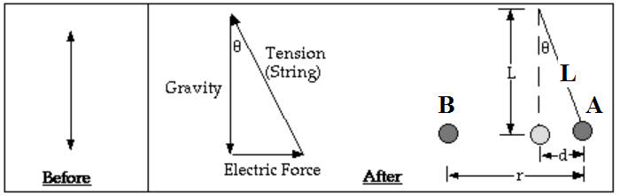

**Figure 8:** Deflection of the suspended pith ball, labelled A by an equally charged pith ball labelled B.

From Figure 7 d/L = sinΘ and the force in the x direction pushing on the pith ball is

F = mgsinΘ.

1. Use the above information to derive a formula that shows that the electrostatic force is directly related to the distance d that the pith ball is deflected. ( 1 marks )
2. Next use your equation from (a) to show that the square of the distance between two pith balls R2 is inversely proportional to distance the pith ball is deflected, d. Isolate for R2 and rearrange the equation to determine the gradient of the line if you plotted R2 on the y-axis and 1/d (or d-1) on the x-axis. ( 3 marks )
3. Fill in the missing values in the table below. ( 2 marks)

|  |  |  |  |  |  |  |
| --- | --- | --- | --- | --- | --- | --- |
| Ruler position of the suspended pith ball prior to being charged (cm) | Ruler position of stationary charged pith ball  (cm) | Ruler position of the suspended,  deflected pith ball (cm) | R  (m) | R2  (m2) x 10-3 | d  (m) | 1/d  (m-1) |
| 7.00 | 1.50 | 7.90 | 0.064 |  | 0.009 |  |
| 7.00 | 2.00 | 8.01 | 0.060 |  | 0.010 |  |
| 7.00 | 2.80 | 8.30 | 0.055 |  |  |  |
| 7.00 | 3.20 | 8.40 | 0.052 |  | 0.014 |  |
| 7.00 | 3.80 | 8.60 |  |  | 0.016 |  |
| 7.00 | 5.35 | 9.36 | 0.040 |  | 0.024 |  |
| 7.00 | 6.06 | 9.76 | 0.037 |  | 0.028 |  |

1. Graph R2 on the y-axis and 1/d on the x-axis on the graph paper on the next page. Additional graph paper is supplied at the end of this question if required.

( 4 marks )

1. Draw the line of best fit and determine the charge on the pith balls given that the pith ball has a mass of 2.00g and the length of the string is 50 cm. ( 3 marks )

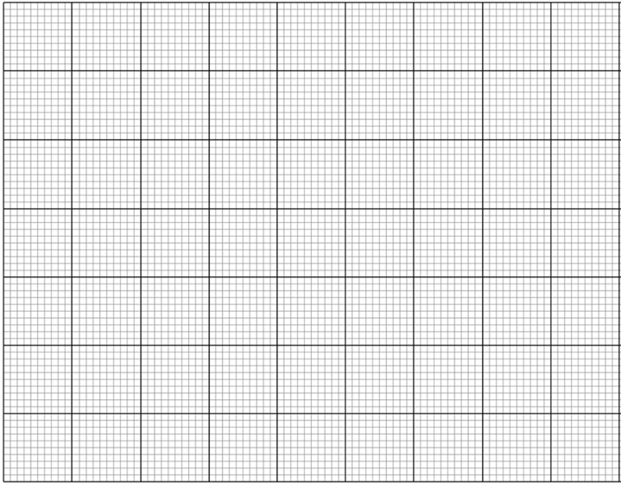

In another version of the PSSC type apparatus the pith ball is suspended by two strings. Refer to Figure 9 below.

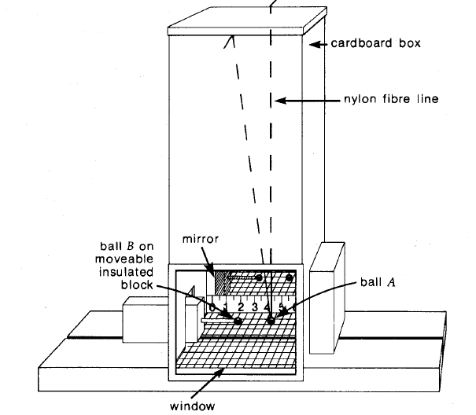

**Figure 9:** PSSC-type Coulomb’s Law Apparatus

1. 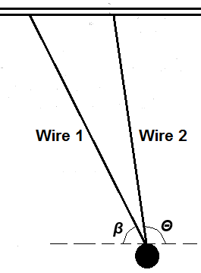When a 8.00 mN electrostatic force acts horizontally on a pith ball the following equilibrium occurs, with the following angles being created, *β* = 60o and *Θ* = 110 o.
2. If the tension in wire 1 is 9.513 mN what is the tension in wire 2? ( 2 marks )

ii. What is the mass of the pith ball in grams? ( 3 marks )

